Unit 8 – Gradient Cost Function Summary
Objective – By changing the learning rate and iteration number observe how cost decreases.
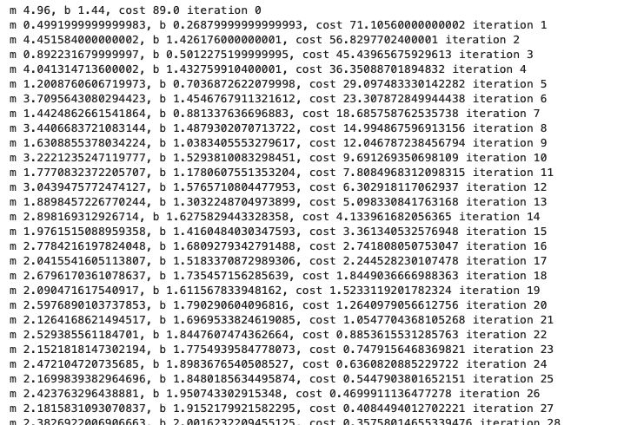
Original input above has 100 iterations and a learning rate of 0.08.

Key takeaways:
- As compared to the original input If you increase the learning rate and decrease the iteration number (50 iterations and a learning rate of 0.16) the initial cost is steep but drastically falls as you reach the tail end of the iterations.
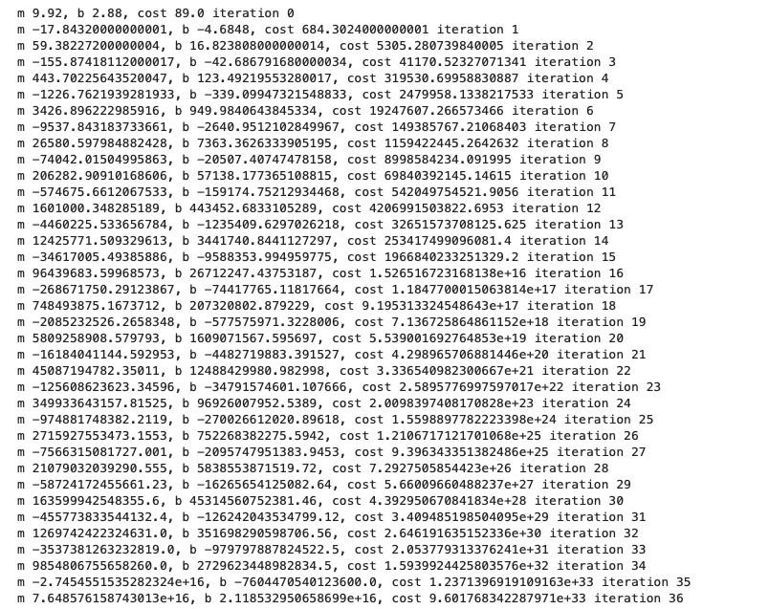
- As compared to the original input If you decrease the learning rate and increase the iteration number (150 iterations and a learning rate of 0.04) the cost is significantly low from the outset just more iterations.
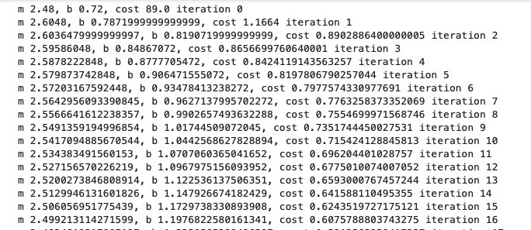

- If you increase the learning rate and increase the iteration number (150 iterations and a learning rate of 0.16) cost is steep in the early iterations but drastically reduces by the time you get to the last iteration.
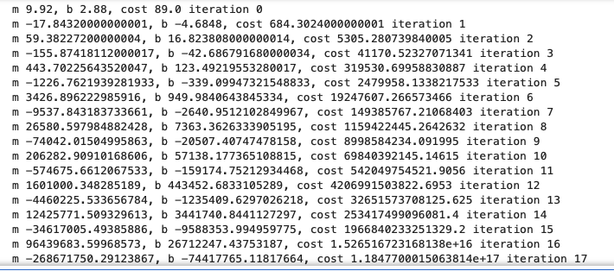

- If you decrease the learning rate and decrease the iteration number (50 iterations and a learning rate of 0.04) cost significant drops but with fewer iterations.
